Name Social Studies; Document

Date **Cloze Notes—Ancient Egypt Ch.2, Sec. 2**

T

he Old Kingdom began ___________ BC and ended ___________ BC.

[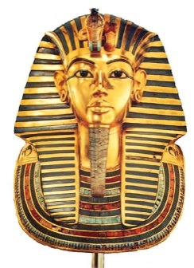](http://www.google.com/url?sa=i&rct=j&q=&esrc=s&frm=1&source=images&cd=&cad=rja&docid=b-KFFWxdKtGteM&tbnid=bhFZdm_2ikDT0M:&ved=0CAUQjRw&url=http://www.mystudios.com/art/ancient/egyptian/egypt-tut.html&ei=PxF1UujRJ4K0sATsyIC4BA&bvm=bv.55819444,d.cWc&psig=AFQjCNEoKKLmuPbWGtBMoVVp8RTEnLTtGA&ust=1383490222469944)During that time cities ____________ and trade _____________.

Kings set up ____________ governments.

Egyptian kings were known as ________________.

They lived with their _______________ in grand _______________.

__

P

haraohs appointed many ______________ to do their work ________________ taxes, see to it that crops were planted, _________________ canals dug, and food stored.

Egyptians thought their pharaoh was a __________.

He carried out certain ____________ that were believed to benefit the _____________________.

[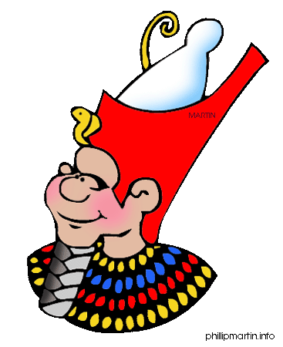](http://www.google.com/url?sa=i&rct=j&q=&esrc=s&frm=1&source=images&cd=&cad=rja&docid=QeTppOVfmY7VkM&tbnid=w_JWv-RMRf01_M:&ved=0CAUQjRw&url=http://www.proprofs.com/quiz-school/story.php?title=ancient-egypt_33&ei=Sv50Ut-dN7W-sQSb4oGQBA&bvm=bv.55819444,d.cWc&psig=AFQjCNEbEXE_wDzKQ9TIUqajcAiKF7xhew&ust=1383485306260711)

E

gyptians thought their pharaoh was a _______.

He carried out certain ____________ that were

believed to benefit the ________________.

Religion was deeply _________ into Egyptian culture.

Ancient Egyptians ___________________ many deities.

**Factoid:** The Nile River is the longest river in the world and is filled with fresh-water crocodiles! Swimmers beware!

The main Egyptian god was _______.

[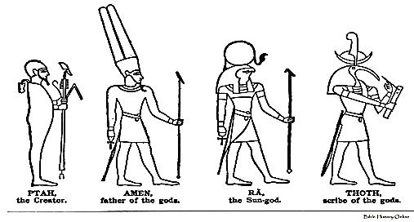](http://www.google.com/url?sa=i&rct=j&q=&esrc=s&frm=1&source=images&cd=&cad=rja&docid=SMpPMVm7FrVJ9M&tbnid=dx3Pe7XqovqudM:&ved=0CAUQjRw&url=http://www.bible-history.com/ibh/Egyptian+Gods/Other+Gods/Gods+and+Goddesses&ei=Xxd1UuStDdDZsASZ0YHABQ&bvm=bv.55819444,d.cWc&psig=AFQjCNHhjOcx6EpEcZBdefZv0ZIGtjIbtQ&ust=1383491803140444)The most important ______________________.

TURN OVER

E

gyptians took a _____________ view of the __________________.

To protect Pharaoh’s body it was ________________. Then wrapped in

*linen*. The wrapped body was known as a _________________.

The mummy was placed in several _______________________, one inside the

[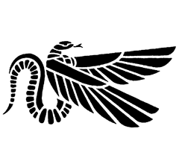](http://www.google.com/url?sa=i&rct=j&q=&esrc=s&frm=1&source=images&cd=&cad=rja&docid=TjyHFXtHCDe7WM&tbnid=wzaYnqixTTS_LM:&ved=0CAUQjRw&url=http://www.joanannlansberry.com/journal/pathmark/serpent-p.html&ei=shp1UovcJY-isAS9hoGgBQ&bvm=bv.55819444,d.cWc&psig=AFQjCNGnQsejAmxNI6b4n7eGXea8zgBMXw&ust=1383492618921370)other, then buried in a ________________.

While ____________ the dead, the Egyptians learned much

about the human body. ___________ learned about

illnesses and setting broken bones. Some doctors became

“_____________” in certain kinds of medicine. Egyptians wrote the first

____________ books on ____________ of papyrus.

[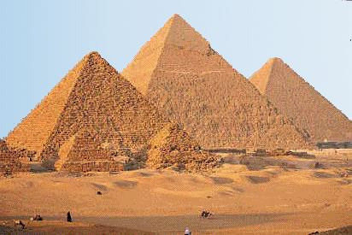](http://www.google.com/url?sa=i&rct=j&q=&esrc=s&frm=1&source=images&cd=&cad=rja&docid=zCk_9eceLUI4gM&tbnid=9_qv3l3OU25XhM:&ved=0CAUQjRw&url=http://rde.nsw.edu.au/rm/specialPlaces/special_places_st2/africa/the_pyramids.htm&ei=5B91Usq-I-awsASEjoGoBQ&psig=AFQjCNFMoRiQfNVnuH2GW7Zwp36pwRvqsQ&ust=1383493490195252)**Pyramids**

N

o ordinary tomb would do for a _________________.

_______________________ monuments called

pyramids were built for the Pharaoh’s _____________.

**The Great Pyramid**

A

bout 2540 BC, the Egyptians built the _____________ and _____________

pyramid known as the Great Pyramid. It was built for

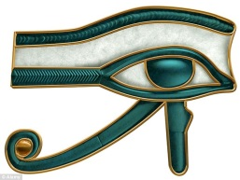King _____________. It was the ______________ structure in the

world for 4000 years! It is equal to a ________________ building.